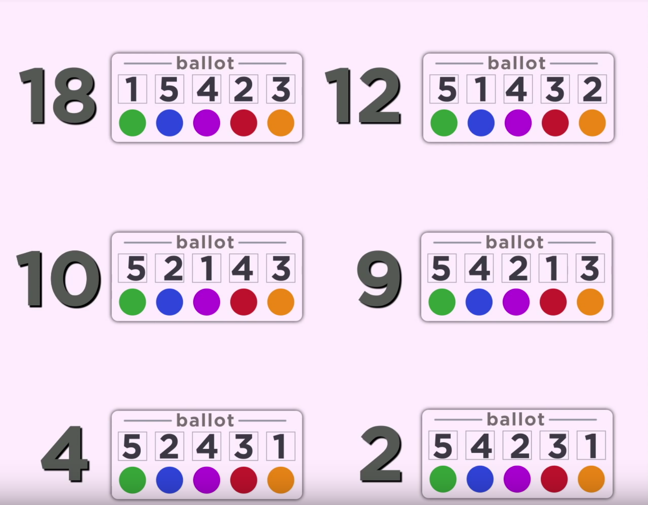

Voting Systems:

1. Plurality
2. Two-round Runoff
3. Instant Runoff
4. Borda Count
5. Condorcet Criterion

Sixth-grade voting

Suppose that there is a sixth grade class, which has 15 boys and 10 girls. Three students are running for class representative, two boys and one girls. Because this is sixth grade, you know that all of the boys will vote for a boy before any woman, and vice versa. Suppose that the women get to choose the voting system. What system should they choose maximize their chances of a candidate winning?

Same question, but this time suppose that the boys are in charge of deciding the voting system.

High-School Pizza

Suppose that the High School I LAMC group wants to order a pizza. The possible toppings are sausage (S), pineapple (P) and extra cheese (E). To keep things simple, we are using a **plurality voting system**.

You asked people what they were going to vote for beforehand, and it looks like the votes will come out as:

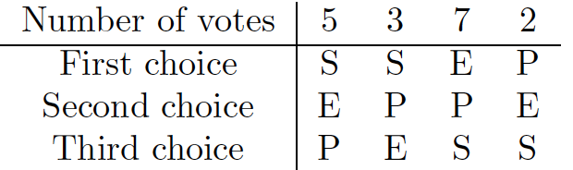

If you and your close friend are the voters in the last column, what should you do? (That is, can you make your choice win under a plurality system?)

Based on your pre-voting polling, which voting system would you advocate for?

American Politics

The American system for electing officials (e.g. presidential candidates) uses two rounds of voting, not just one. In the first round (called the primaries) the various parties (Democrat, Green, Republican, etc...) select the candidate that they will endorse for president (i.e. who will represent their party in the general election).

In the primaries the winner is chosen by plurality. It's not unusual for the primaries to have a LOT of candidates (in 2016, the Republican party had 12 candidates!). Suppose that you wanted to win the primary election (and maybe later the general election). You have two strategies. You could try to appeal to a lot of voters, but not appeal to them very much (call such a candidate a moderate candidate). Alternatively, you could try and appeal a whole lot to small subset of your party (call this an immoderate candidate).

If you want to win your primaries, what strategy is best?

Suppose that you made it through the primaries, and now you are now your party’s candidate in the general election. Suppose that you are running against only 1 other person. Should you try and be moderate, or immoderate?

Often in presidential cycles, candidates (of all parties) start off as very immoderate, and become more moderate as the election cycle goes on. Is this strategy in agreement with your analysis?

Suppose that the primaries and general election winners were not chosen by plurality, but instead by some other method. How would your answers to the above three questions change?

Using the Candy Ballots to Simulate the Electoral College

Direct popular vote may not reveal group preference, especially with an open ballot (vote for your favorite candy).

A representative vote would divide the electorate into groups, and each group casts a vote. One method is that the group chooses a representative and that representative casts the group’s vote.

1. How is the representative chosen?
2. How does the representative decide the group’s vote?

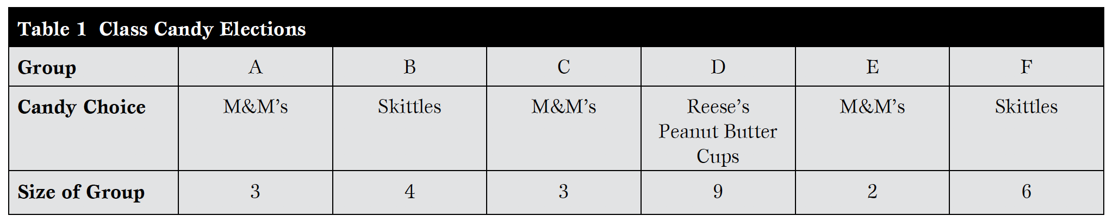

Given the modified “electoral college” in the table, M&Ms wins the election. Issues?

If group size is an issue, how address it?

Suppose we can cast exactly 100 votes in the Candy Election. Based on the table, how should we cast those votes?